BANL 6600 Midterm

M4: Assignment - Mid Term Exam Power BI Project

**Transforming Data:**

Append Three Tables to single table(Total_Sales)

On Product Table:

Added custom column to obtaining Profit column:

Added new column to calculate profit margin and converting that column to percentage type.

Added custom column for Profit_Category

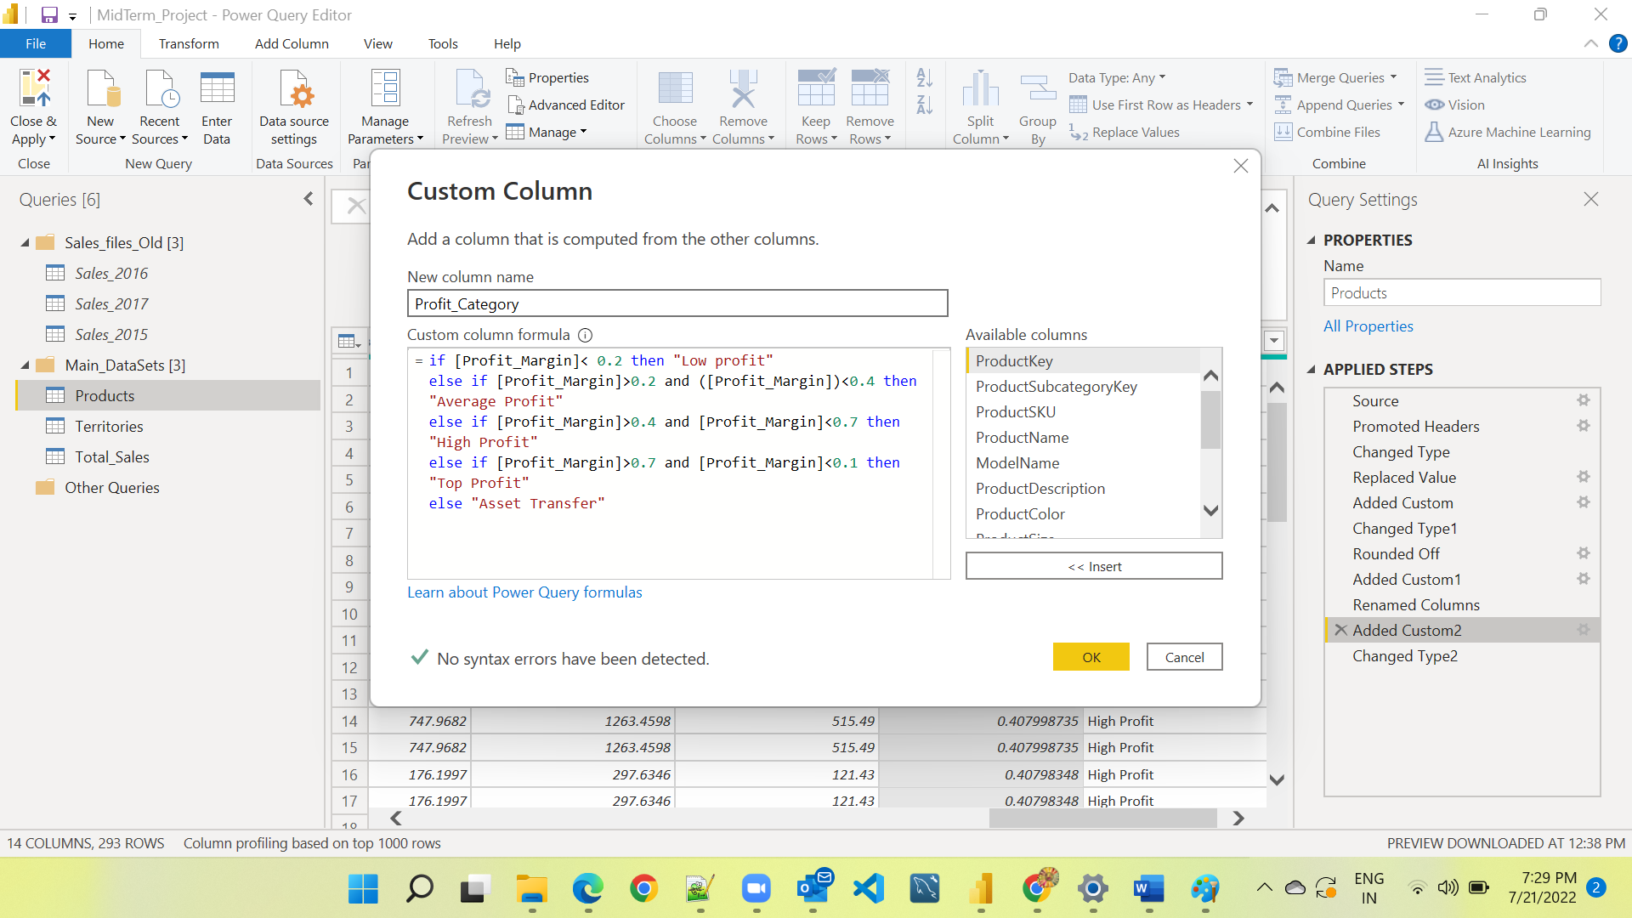

On Territories Table replaced continent value for Australia:

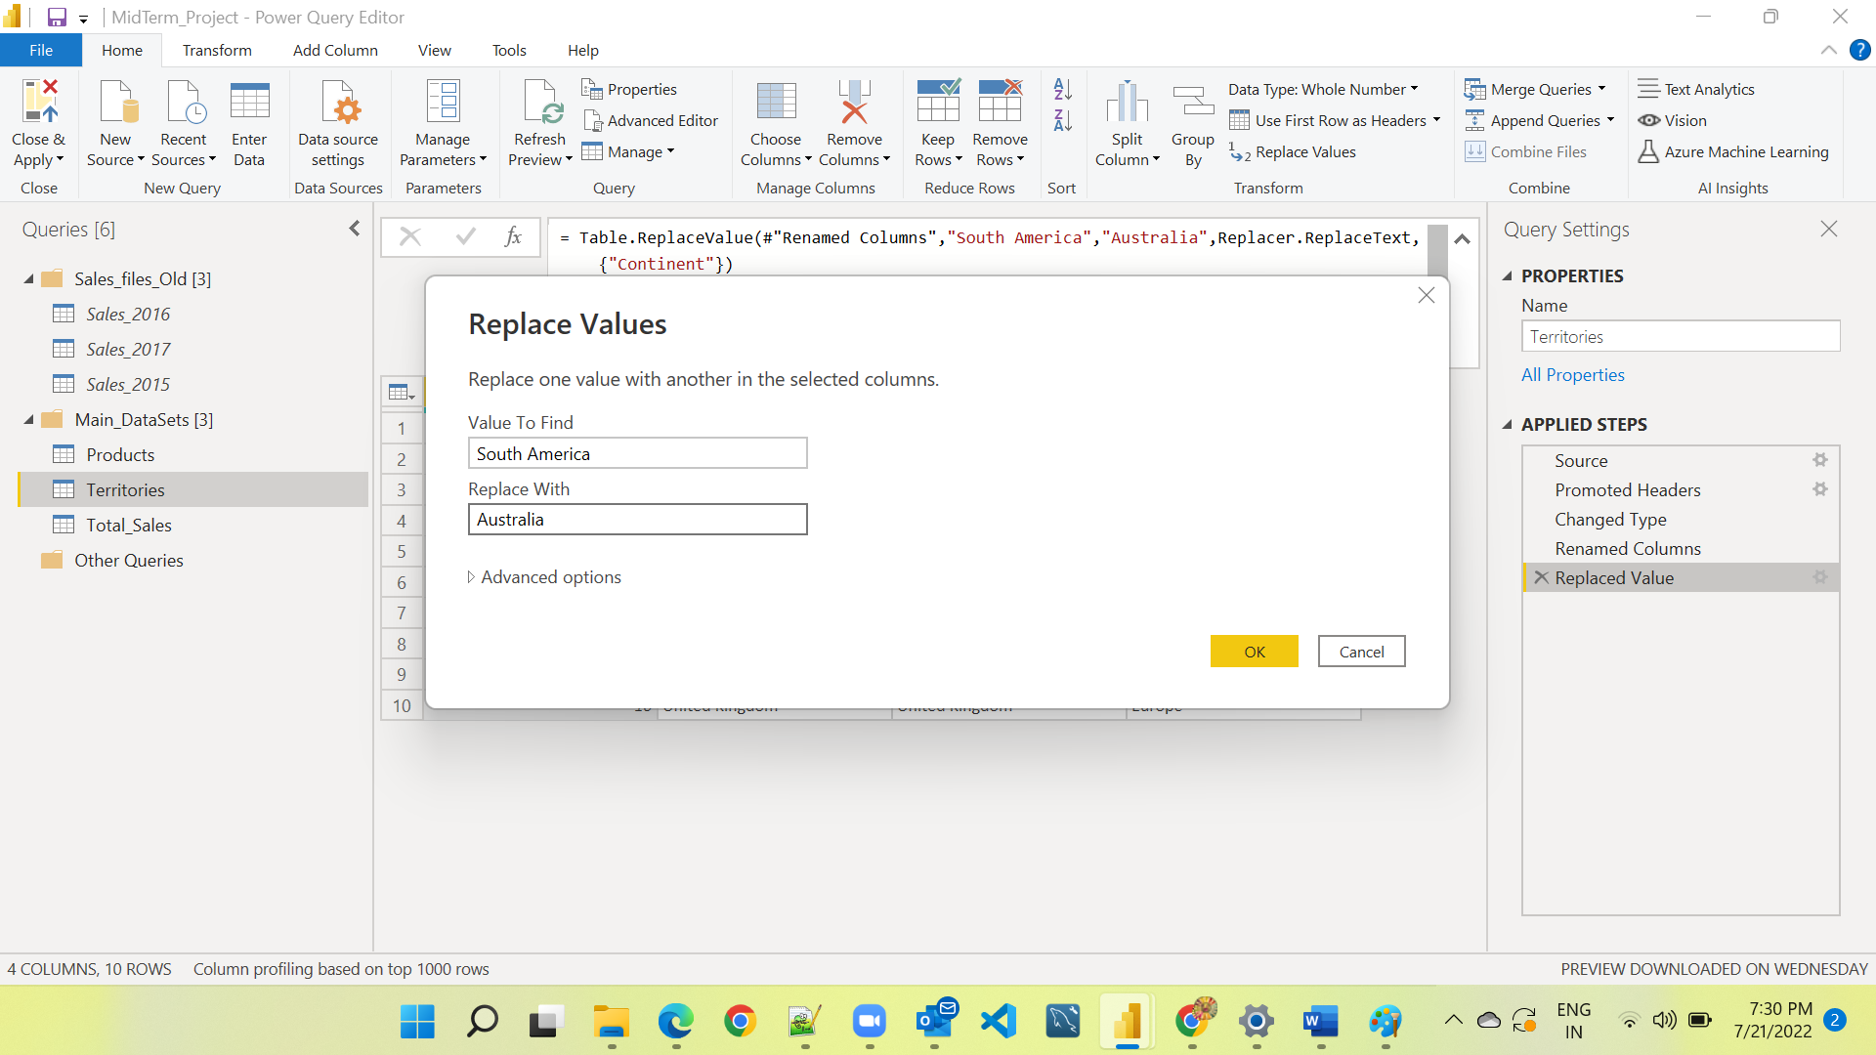

On Report View For data added new column to get prices from Products table:

Product_Price = LOOKUPVALUE(Products[ProductPrice],Products[ProductKey],Total_Sales[ProductKey])

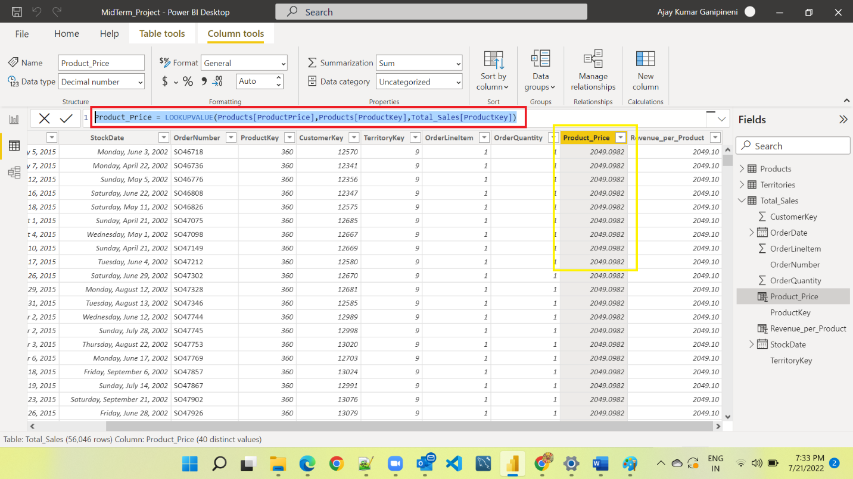

Added one more column to calculate revenue per product:

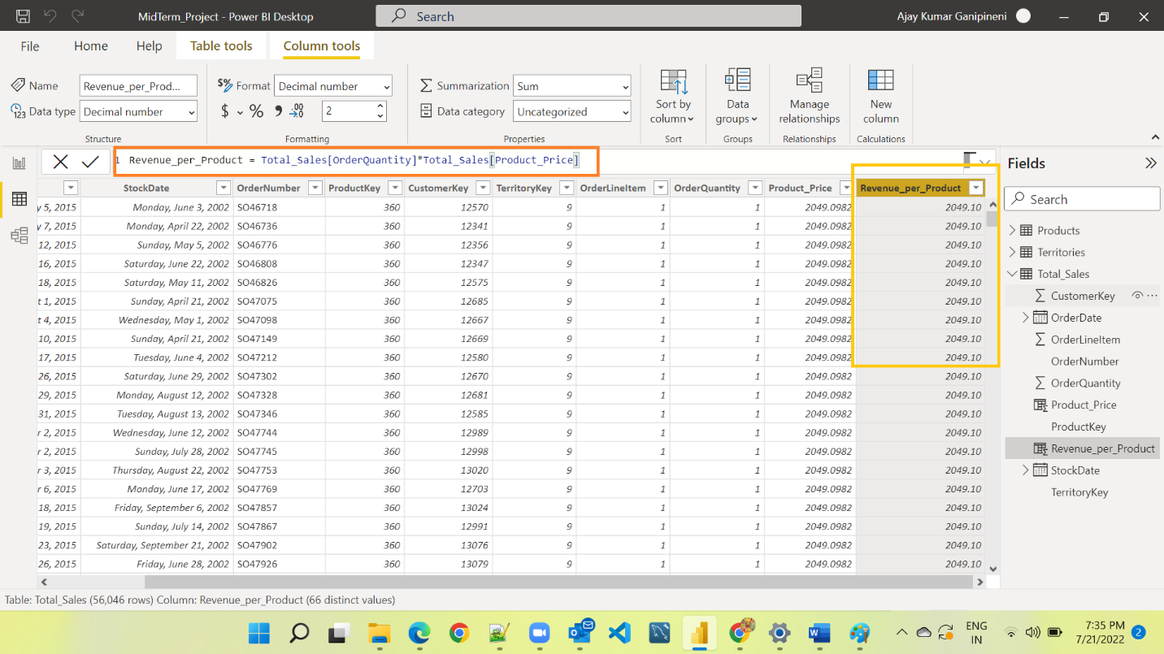

**Data Modeling:**

**Report (Visualization):**

**Published report to Power BI service:**

